Factors Influuencing EmployeeRetention In The Organiztion

Supervised by:
Dr. Naimatullah Shah

Yazeed ALShowaier
201811201
Meshal AlBahli
201821447
Fisal ALAskar
201821448
Table of Contents
Executive Summary 2
Acknowledgment 3
Declaration 4
Chapter one 5
1. Introduction. 5
1.1. Research purposes 7
1.2. Research aim and objectives 7
1.3. Significance of the research 8
1.4. Measurement scales 10
1.5. Research context 11
Chapter Two 12
Literature Review, Conceptual Framework and Hypotheses Development 12
Chapter three 19
Research methodology 19
3.1 Research Method 19
3.2. Population and sample 20
3.3. Data collection. 21
Chapter four 22
2. Data analysis 22
Chapter five 56
Results Discussions, Conclusions, Implications, Limitations and Recommendations 56
Discussion. 56
References. 60
Appendices 67

Executive Summary

The study's purpose was to examine employee retention and how it is applied in different organization levels. Besides, the research was geared towards analyzing employee retention's paramount role that entails promoting efficiency of both long and short-term objectives. The research concept was based on determining the relationship between employee retention and engagement, performance, workplace culture, training, and motivation. The relationship between the above variables aided in proofing that employee retention is a successful motivator and tool for maintaining an enabling environment for employees. Besides, the researcher wanted to prove that employee retention improves the recruitment process by determining employees who fit in particular duty. The methods of the study included a structural design that aided in understanding the factors influencing employee retention. Descriptive research was the second method of study that helped the researcher collect evidence to help analyze collected data and come up with favorable results. During data collection, the researcher gathered information from a sample of the overall population collected over a specific period using questioners and interviews. Data collection involved 162 participants, where the researchers extracted the sample from the Saudi population through the use of questionnaires distributed to everyone within the organization. The first set of results was derived from Pearson correlation, where all variables were positive, with values ranging from 0.246 to 0.72, suggesting that employee retention is vital in attaining long-term organizational objectives. The second set of results came from the regression analysis that generated an R-value of 0.377. The research concluded that employee retention depends hugely on their engagement, performance, workplace culture, training, and motivation. The research's final recommendation was that organizations should balance the above independent variables tactically to attain employee retention.

Acknowledgment

The authors wishes to express their gratitude to Dr. Naimatullah Shah for his priceless contributions of guidance, patience and constant encouragement.
Special thanks and gratitude are expressed to the writers’ families for their support, encouragement and understanding during the course of this work.

Declaration
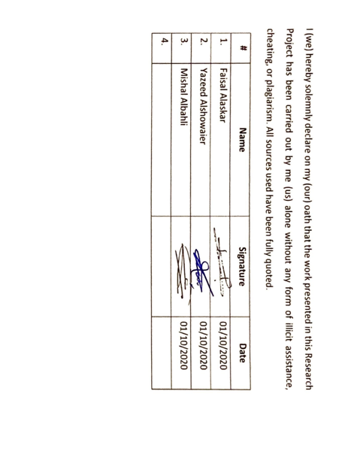

Chapter one
Introduction

Introduction.
Retention of employees refers to the ability of a business firm or an organization to keep the employees. Employee retention can also be viewed as a strategy where an organization attempts to retain employees at different levels of the organization. Employee retention is very important in every organization because it ensures that organizational long-term and short-term goals are achieved within the required amount of time. According to the bureau of labor statistics (2020), seventy-two percent of the organizational values are brought by employees. Therefore, allowing employees to turn over leads to the loss of important skills, knowledge, and experiences. The executive is responsible for ensuring employee retention is at a maximum level. An increase in the number of better job opportunities, availability of online jobs, off-shoring and increase in co-operate recruitment leads to employee turnover which leads to losses within an organization since a lot of time and effort have to be put in to get replacements for the employees that left the work and training the new employees. Employee turnover refers to the number of employees that leave a particular organization and are replaced by novel employees. According to research done by (Ambitions, 1995), at least nineteen percent of employees leave their organizations for new jobs.
Employee turnover may be due to the following reasons. Firstly, lack of career growth and progress may cause an employee to change careers or move to a newer organization that appreciates their efforts. Secondly, working overtime with no extra pay kills the motivation of some employees thus encouraging them to move to other business organizations. Moreover, a lack of feedback or recognition and support from project managers shows the employees that the organization is not investing in their jobs hence they lack the motivation to continue working. Also, the absence of rewards for work-well-done and compensation for sick leaves or work accidents makes the employee think that their well-being is not guaranteed in that particular organization. Besides, if an organization does not offer opportunities for promotions and room for decision making for some management employees may cause those employees to move to new firms and organizations. According to (Michaels et al, 1982), observing the commitment of an employee to the organization and their expectations from that particular job highly assists the management of an organization to determine whether the employees are highly satisfied with their jobs and whether they have the intention of quitting their job in the near or far future. Therefore, every organization should come up with proper retention strategies to ensure that little or no employees leave the organization.
A retention strategy is defined as a set of rules and policies that an organization adheres to reduce the rate of employee turnover and increase the rate of retaining important employees. The main objective of a retention strategy is to ensure that the prospects of all workers are considered without tampering with both the long-term and the short-term goals of the organization, and ensure that the return on investment is maximized. Organizational strategies for retention have the following five drivers: To enable the fulfillment of the employees towards taking that job, to offer opportunities where employees can grow intellectually, psychologically, and in their careers, to empower responsible and hardworking employees through the provision of rewards and promotions, to ensure collaboration between employees of all levels within the organization, and to encourage organizational processes to lead to successful organizational operations. Based on a research by (Deery et al, 2015), the most organization uses a strategy of incorporating the features of the organization, personal dimensions of employees, strategies of the organization and, conflict with employee work-life difficulties to determine whether the job satisfying them, determine how to improve employee commitment to the organization and, how to reduce turnover of employees. Also, these strategies may ensure that employees can grow their careers, where their cultural and social values are respected, get constant training and health benefits, and have proper working environments. Therefore, this research paper focuses on analyzing the factors influencing employee retention in an organization.

Research purposes

Among the major reasons for conducting this research was to help organizations promote productivity, hence maintaining hardworking yet responsible employees. The second purpose of this research was to boost the organization's recruitment process since qualified employees execute the company’s duties diligently hence retention (Liang, 2013). Besides, organizations can utilize the research results to promote employee motivation and morale (Sinha & Sinha, 2012). The research will assist the company's executives in understanding factors that enhance employee motivation, including overtime payment, building teams, rewarding, and promotions, as well as offering paid leaves (Sinha & Sinha, 2012). Managing employee turnover was another purpose for conducting the research. Employee retention aid organizations in achieving workforce turnover due to growing careers, offering promotions, and assisting in gaining experience and mentorship services. Another purpose of the research was to assist organizations in reshaping employees to experts.

Research aim and objectives
Among the major objective of the research was to establish the effect of workplace culture on employee retention. According to Aguenza & Som (2012), workplace culture defines employee's retention as the freedom in expressing their needs. The second objective was to establish how training influences employee retention. Kaur (2017) opined that organizations could have long-term employees by reshaping their skills based on the industries' demands. The third objective was to assess how the availability of motivation influences employee retention. Precisely, the organization's executives should emphasize on creating a positive working environment by motivating employees consistently (Kaur, 2017). Precisely, the research was partly geared towards determining whether better-performing employees have a long term relationship with their employer. The fourth objective was to analyze the influence of job performance on employee retention. The last objective was to assess the influence of work engagement to employee retention.

Significance of the research

Understanding the significance of the research on employee retention plays an important role in a business organization. That is, it is a motivator for the success of an organization, and understanding proper programs for employee retention ensures that vital employees stay within the organization. Therefore, this research is important because of the following: Firstly, it helps the organization determine ways of boosting their productivity and maintain responsible and hard-working employees. That is, the higher the number of employees retained by an organization, the higher the productivity of the organization since the level of operational activities is also increased. According to (Malik et al, 2013), an increase in the rate of employee retention leads to an increase in organizational productivity while an increase in the rate of employee turn-over reduces the general rate of productivity.
Secondly, it may help organizations improve their process of recruitment. Retention begins at a very early stage in an organization. Determining what employees expect from a particular job and the commitment they had with the previous organization may help the human resource department determine whether a person is suitable for that particular firm. According to a study by (Deery, 2009), every organization, whether in a public sector or the private sector needs to find employees that have similar interests with the organization so that they can voluntarily stay with the organization because they would need little or no convincing.
Moreover, this research would help the most organization understand how to improve the morale of their employees. For instance, developing team-building activities, rewards, paying for extra hours, offering promotions for those who deserve it, and providing paid leaves will show the employees that the organization cares about them. Therefore, providing supportive conductions in workplaces will improve socialization amongst employees and participation in the work-ethic activities that improve commitment (Weiss, 1999).
Moreover, this research is significant because it helps the organization manage employee turnover. Even though there is no common way for comprehending the concept of employee turnover, the organization can still manage to control the levels of turn over. According to research by (Sullivan et al, 2013), employees are attracted to an organization based on chances of growing their careers, securing promotions in the future, obtaining experiences, and mentoring. Moreover, he argues that employees are likely to leave an organization for greener pastures if their physical, mental, and environmental conditions are not taken care of. This is because employee turn-over and retention maintenance have grown to be the greatest issue in every organization (Rizwan et al, 2014).
Besides, this research may help the organization attract quality employees. Quality employees refer to those workers within the organization that possesses leadership skills, have good verbal communication and written skills, are intelligent, have an active listening skill, are honest, ambitious, hard-working, and have a strong work ethic. Good quality employees create a conducive environment for working, are highly productive, and help reduce the cost needed for the training of employees. Therefore, to attract quality employees, the executive of a company should evaluate the culture of the organization to attract employees that are comfortable with the culture. Moreover, the organization can make clear the goals, mission, vision, and value statements known in application websites, so that employees can know what is expected by the organization before they apply for the job. Based on a study by (Herman, 2005), attracting good employees has been a hard task since the 1990s. This is because people were moving from job to job as they please due to the availability of a lot of jobs. Therefore, organizations experienced a lot of difficulties getting good employees and when they got them, they would easily move to a new job or organization that provided better benefits or pay. This made the rate of competition in the retention of employees high. Therefore, organizations can offer better benefits to attract and retain employees, such as health and life insurance, paid leaves and vacation and, potential promotions.

Chapter Two

Literature Review, Conceptual Framework and Hypotheses Development
Factors affecting employee retention
Retention of employees is essential in today's business world; hence some motivational factors and strategies are crucial in ensuring that employees are motivated and retained. The article discusses the strategies that can be used to motivate and retain employees and the psychological factors that affect employee retention. Recognition of employees, the managers' strategy in management, and ensuring a proper work-life balance are some of the strategies used in ensuring employee retention (Aguenza & Som 2012). These factors are essential in ensuring that employees are motivated to ensure the organization's success since motivated employees are highly productive.
Employee retention factors in Nepali insurance companies
Highly productive employees need to be retained in the organization (Ghimire 2018). The study was conducted to identify the factors that influence the retention of employees, which include compensation strategy as a reward for employees and creating a harmonious environment. These factors can help retain employees in the insurance sector. The findings show that lack of employee retention can result in manpower crunch. Salary and benefit for employees, work-life balance, and career opportunities to advance the employee's skills greatly impact employee retention since they help motivate employees as found out in the research.

Recruitment, employment, retention, and the minority teacher shortage
The research was conducted due to the shortage of minority teachers experienced in the country. Whether the number of teachers changed, the places where they are employed, the turnover of the teachers, sources of the teachers, and the role that the stuffing of the teacher's plays is areas which were investigated in the research. The research was done in various schools, and the findings were that the recruitment and retention of the minority teachers are low hence causing the shortage of teachers and poor performance by students (Ingersoil, May & Collins 2019). Ensuring the recruitment and retention of the teachers will help to maintain the number.
Role of employer branding dimensions on employee retention
Every organization competes for the best talent available for the excellent performance and a competitive advantage over the other organizations. The journal states that branding is done by ensuring the acquisition of the best resources by the organization to improve its competitiveness. According to Hadi & Ahmed 2018), a good employer brand involves managers' good experiences with the employees and helps the best talent available in the market, hence improving productivity. Branding helps to improve the recruitment process and improve the organization's reputation and employee loyalty.
Factors influencing employee's intentions to stay in the organization
The intentions to stay in an organization are determined by the organization's efforts to decrease the effort by employees to leave. According to the journal, Compensation and benefit policy in the organization have the greatest impact on the intentions to stay. The factors are either internal or external. Training and development and performance management systems also affect the intentions to remain (Goperma &Dolai 2018). Well and satisfied employees who feel a sense of belonging in the organization are less likely to leave. An organization culture that is favorable for the employees is important for employee retention.
Employee retention. A literal review
Attainment of the best talent by the organization is equally important as the retention of talent since the best talents are required for the organization's productivity. The journal shows that proper compensation and reward systems led to employee retention. Das &Baruah (2013) asserts that Promotions and employees opportunity for growth, good leadership, and participation in decision making influence employee retention and a proper balance of the work-life. The appropriate working environment and job security of the employees contribute to their remaining in the organization. According to the journal, proper job satisfaction led to a low employee turnover rate.
Role of gender in employee retention.
The importance of gender in determining voluntary turnover has shown that female employees are likely to have high turnover rates than male employees. This is because most of the female employees look up to their spouses for financial support. The male employees remain aware of the compensation and benefits policies, while female employees see gender biases in most organizations (Nasir, Ashraf &Riaz 2019). Hence most of them are not loyal to the organization. There's also the problem of the gender pay gap. Female employees are paid less than male colleagues, even though they have equal roles.
Determinants of employee retention.
Supervisor support is highly needed by the employees for them to feel appreciated and valued in the organization. The more the supervisors' support, the higher the retention of the employees, whereas the less the support of the supervisors, the lower the retention. According to Nasir &Mahamood (2016), providing career growth and development opportunities will increase retention rates. Therefore an organization should offer such opportunities. Rewards and recognition of employee's efforts and performance will always make them stay. Good working conditions and the environment will give employees a reason to stay. Job satisfaction and work-life balance too.
Challenges and retention plans.
According to the Journal of Recent Technology and Engineering, some of the challenges are the rapid technological changes across the globe. The world has gone digital. Pay-gap between spouses is leading to an increase in the shift of jobs from one place to another. Compensation and benefits play an essential role in the retention of employees. Most employees tend to shift to jobs with better salaries and non-financial benefits (Nayak &Ben 2019). Job satisfaction, work-life balance, and family pressure are some of the challenges too. Some of the retention strategies include training and development, career growth, and performance management of employees.
Underpinned theories.
Employees leave one organization to another due to intrinsic rewards or extrinsic rewards. Organizations craving to retain employees should focus on integrating both intrinsic and extrinsic rewards for maximum employee satisfaction. Herzberg's theory states that certain factors are directly related to the job, while some are non-job related, yet they both provide satisfying experiences for employees (Harada et al. 2017). Social exchange theory states that social exchange is a process that takes place when individuals have mutual interaction with one another, and through this exchange, they can depend on each other and be responsible for the other
Factors influencing employee retention in multinational companies
Employee retention is a challenge faced by employees in international organizations. International companies require IT professionals, which make the professionals high; hence, companies compete to acquire the best employees in the global market; therefore, strategies have to be put in place to retain them(Sundar 2019). Factors influencing individuals to stay in an organization are categorized for individual reasons and organizational reasons. Having proper recruitment and retention strategies by the organization helps to attract the best talent to the organization. Such a plan includes career development, ensuring a work-life balance, and employee compensation.
Factors affecting employee's satisfaction in Ghana industry
Today's business world depends on well-skilled employees to succeed in the competitive world; hence it is essential to ensure that strategies are put in place to ensure that employees are satisfied in their jobs to enable them to stay in the organization for long (Deri et al. 2016). Employees' development to improve their skills and proper compensation system are factors that affect employee satisfaction in Ghana, as stated in the journal. The research showed that flexible working time and the managers' ability to effectively solve problems in the organization improved employee satisfaction.
Factors that determine employee retention
Factors that determine employee retention can be divided into individual and firm elements. Individual factors include gender, where Women are often considered less valuable than their male counterparts, marital status as married individuals tend to make complicated employment decisions as they have a lot to consider. According to Wachira (2018), Education organizations provide scholarships to employees to further their skill set. Firm factors include sound organization culture, a good and conducive working environment free of hazards that will harm the employees. Ideal and fair wages, as well as. Strategies offering financial aid, offering bonuses for a job well done, and also promotion speed.
Effects of organizational culture on turnover
A good and supportive organizational culture led to well satisfied and committed employees hence reducing turnover intentions by employees. Supportive culture led to job satisfaction, thus reduced intentions to leave the organization. Improved working conditions for employees and proper management strategies like involvement in decision making are indicators of an excellent organizational culture (Niguse 2019). Well stated and implemented policies of the organization and a well-implemented strategy to retain employees is has a positive impact on employee turnover. The employer needs to be well connected with the employees to ensure a proper organizational culture.
Factors influencing employee retention in companies
Due to the increased competition in today's business world, an organization needs to retain the employees. According to the journal, when employees leave the organization, they leave with the skills and talent; thus, employees should be motivated to stay in the organization. A favorable working environment and proper wages and compensation help to retain employees. Rakhra (2018) Ensuring job satisfaction for employees and job security for their employment are factors that influence employees to stay in the organization, provide employees with career development opportunities, and offer a proper work-life balance for employees.
Research Model
A research model represents the structural design to help understand the factors that influence employee retention. This research involved the utilization of a descriptive research methodology, to assist the researcher collect evidence to help analyze collected data and come up with favorable results. This research study aims at evaluating the factors that influence the retention of employees in an organization. The specific objectives of the research include: to establish the effect of workplace culture on employee retention, to establish how training influences, employee retention, to assess how the availability of motivation influences employee retention, to analyze how job performance influences employee retention and, to assess how work engagement influences employee retention.
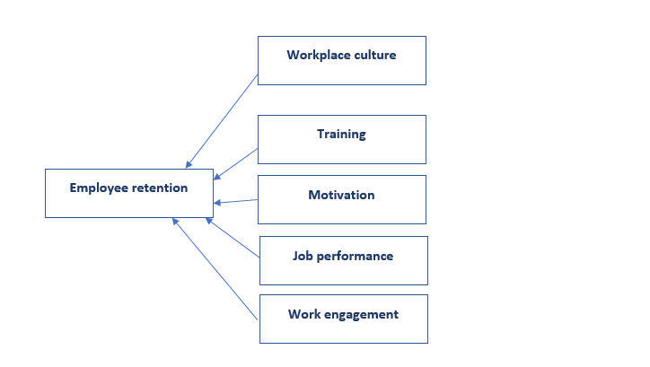

HYPOTHESES DEVELOPMENT
Hypothesis 1.

Hypothesis 2.

Hypothesis 3.

Hypothesis 4.

Hypothesis 4.

Chapter three

Research methodology

Research Method

A research methodology is a collection of methods, practices, procedures, and rules that are used in carrying out research work in the field. This part of the research describes the procedures and methodologies that were employed in this study. It gives details about the site, the study design, methods, and tools of data collection, as well as how the data was collected (Mugenda, 2008). It also gives details on the tools in the implementation of the strategies to ensure employee retention.
A research model represents the structural design to help understand the factors that influence employee retention. This research involved the utilization of a descriptive research methodology, to assist the researcher collect evidence to help analyze collected data and come up with favorable results. Survey research involves researching by use of a survey to gather data from a sample of the overall population collected over a specific period. Therefore, this research study aims at evaluating the factors that influence the retention of employees in an organization. The specific objectives of the research include: to establish the effect of workplace culture on employee retention, to establish how training influences, employee retention, to assess how the availability of motivation influences employee retention, to analyze how job performance influences employee retention and, to assess how work engagement influences employee retention.
3.2. Population and sample
Population refers to a group of units counted in a census or from which a sample is drawn. It may be a collection of people, events, animals, and objects that cat as part of a research. The data for the performance of this research was collected from Saudi population through the use of questionnaires distributed to everyone within the organization. A total of 162 samples were collected which comprised 27 items related to the five strategies of improving employee retention. 107 participants were male, and 55 participants were female. The participants were of ages 31 to 50 with the educational qualifications of a bachelor's degree and master's degree. The participants had working experience of one to six years.

Measurement scales

A measurement scale is a tool utilized to quantify and qualify data variables in statistics. Measurement scale plays a significant role in research since it determines the appropriate technique for data analysis. Among the significant characteristics of a measurement scale is an identity that is used to identify the gender aspect of a population. As such, the identity scale was utilized to distinguish whether a person was a male or female. The ordinal scale is evidenced in the research where the respondents were supposed to answer a question based on the following rates; strongly disagree, moderately disagree, neither agrees nor disagrees, moderately agree, and strongly agree. The ordinal scale was utilized in the research to measure the strength of the independent variable's contribution to attaining employee retention. For instance, the research’s results revealed that employee engagement was a factor that positively influenced employee retention with a mean of 7.33, followed by employee performance with 5.88 (Kaur, 2017). The ratio scale was the last measurement factor that helped the researcher determine the percentage of respondents based on their ideological contribution towards various independent variables.

Research context

A research context is a set of arguments or ideas geared towards making a broader view of the reader's problem statement. The research context utilized in the paper was based on the historical approaches applied in organizations and other researchers' opinions. According to Aguenza & amp; Som (2012), the study's primary research problem was evaluating the factors that influence the retention of employees in an organization. After the problem was analyzed, the researcher was supposed to establish the effect of workplace culture on employee retention, establish the influence of training on employee retention, respondents' age availability of motivation influences employee retention, to analyze how job performance influences employee retention, and, to assess how work engagement influences employee retention. According to the literature, employees contribute up to 72 percent of the organization's operations, thus aiding in achieving goals more efficiently (Kaur, 2017). Besides, the literature outlines the significance of employee retention as a success motivator (Aguenza & amp; Som, 2012). The research context was again aimed at confirming that employee retention improves the recruitment process by determining employees who fit in a particular duty.

3.3. Data collection.

Data were collected through the administration of questionnaires. A questionnaire refers to a form, with a list of questions whose main purpose is to help gather information for research purposes. Questionnaires are most favorable because it is inexpensive, are practical, they offer a quick way to get results from the participants, easy scalability and comparability, and easy analysis and visualization of the results. Questionnaires were distributed through work emails to all stuff that was eligible to participate in the research. The questionnaire involved seven sections: demographic information, ecological factors, work environment factors, health and safety factors, organizational culture, training, and the conclusion sector. The questionnaire involved a combination of open-ended and closed-ended questions that helped in getting a high response rate and enable the participants of the research to express their personal opinions about the question

Chapter four
Data Analysis

Data analysis

Research analysis refers to the activities involved in making sense and finding meanings of the data collected during qualitative and quantitative research. It encompasses the methods involved in the interpretation of the data collected by using logical reasoning and performing analytics to find patterns, relationships, and trends (Tesch, 2013). Data analysis is performed through the following steps. Firstly, the researcher needs to define the objectives of the research so that the analysis aims at satisfying those objectives. For instance, the objectives of this research were to: to establish the effect of workplace culture on employee retention, to establish how training influences employee retention, to assess how the availability of motivation influences employee retention, to analyze how job performance influences employee retention and, to assess how work engagement influences employee retention. The second step of data analysis involves posing the questions you would like your research to answer. For instance, the research questions for this research involved the following: what is the effect of workplace culture on employee retention? how does motivation influence employee retention? How does motivation affect employee retention? How does job performance influence employee retention? How does work engagement influence employee retention?
The third step of data analysis involves identifying the data collected from various sources. For instance, data can be collected from organizational reports, insurance reports, and health reports. That is this research involved the collection of data from the employees of the organization, organizational health and financial records, and insurance information from the related insurance company. After reviewing the data collected, data analysis involves data scrubbing. Data scrubbing taking of data collected from different sources in different formats to find clean and useful information. The clean data is then imported into data analysis tools that give the researcher the ability to locate patterns and answer questions that may arise. Lastly, the cleaned data is then used to make predictions conclude the research (Bailey, 2008). For instance, the analysis involved making conclusions about the strategies to ensure employee retention is maintained or improved within the organization.
Research analysis plays an important role in any organizational project. That is, it helps an organization to come up with better decisions. For quantitative research, data analysis is done through content analysis, narrative analysis, discourse analysis, and grounded theory. Content analysis is dependent on research questions to predict results and it analyses documented information. Narrative analysis analyses data gathered from interviews, surveys, questionnaires, and observation. Discourse analysis observes data from social contexts and interaction focusing on daily lifestyle and grounded theory involves using theories to explain similar occurrences of events (Sgier, 2012)
This chapter focuses on the aims at explaining the methods used for analysis to comprehend the factors that influence employee retention in an organization. It explains the use of descriptive analysis to do statistical tests, the use of Cronbach's Alpha test to test hypotheses. The research also does Pearson's correlation test and multiple regression analysis. The general process involved screening and checking the collected data for accuracy, completeness, and understandability. The data was then summarized, through frequency distribution tables.

Demographic analysis.
Gender
The written questionnaires were sent out to employees of the organization and led to a total of N=162. The total number of women answering the survey is 55 (approx. 44.0%), with the total of men being 102 (approx. 66,0%) answered.
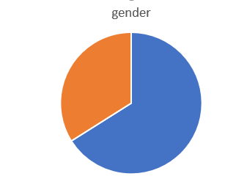
Age of respondents.
Most of the respondents (47.0%) are below 31 years, followed by 39.0% being between 31 and 40 years old. The third biggest group (7.0%), is between 41 and 50 years old, while also 7.0% stated being above 51 years.
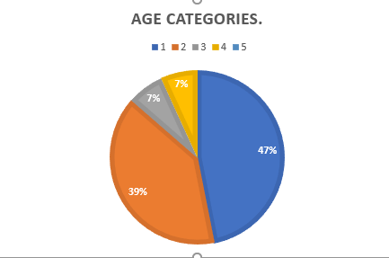
Working experience.
The respondents have had a fresh start at their current employer, being employed for under two year (23.0 %), or for rather short periods of 3 years to 5 years (20.0%) Longer periods were 6 years and above was 57.0%

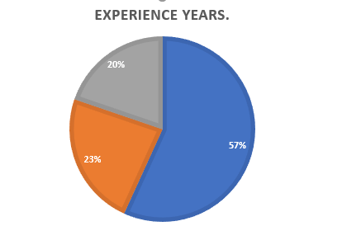
Educational background.
The organizational employees were mostly graduating from bachelors with 66.0% which makes 107 employees and 55 employees with Masters degree forming 34.0%

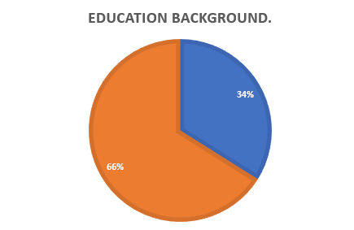

Result presentation.
Q1 – I describe my workplace environment as a culture that is trusting, honest, and fair to all employees.
A total of 52 (32.0%) respondents of the population strongly agreed with the above statement, 35(22.0%) agreed, 40(25.0%) neither agreed nor disagreed, 22(13.0%) disagreed, and 13(8.0%) strongly disagreed.
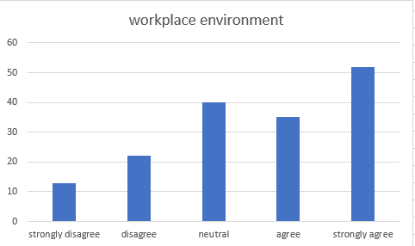

Q2 – I think culture affect behaviors and performance in my organization
A total of 81 (39.0%) respondents of the population strongly agreed with the above statement, 34(26.0%) agreed, 32(24.0%) neither agreed nor disagreed, 10(7.0%) disagreed, and 5(4.0%) strongly disagreed.
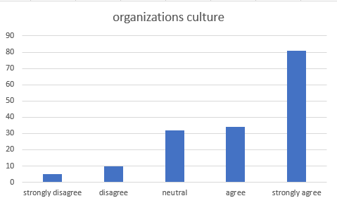
Q3 – Employee involvement is positively related to employee performance and job satisfaction
A total of 74 (46.0%) respondents of the population strongly agreed with the above statement, 51(31.0%) agreed, 30(19.0%) neither agreed nor disagreed, 5(3.0%) disagreed, and 2(1.0%) strongly disagreed.
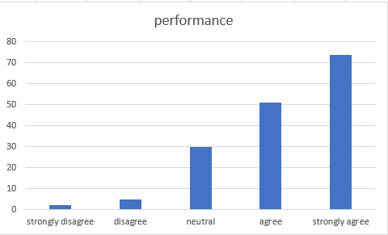
Q4 – My organization measure employee engagement
A total of 53 (33.0%) respondents of the population strongly agreed with the above statement, 33(21.0%) agreed, 36(22.0%) neither agreed nor disagreed, 27(17.0%) disagreed, and 13(7.0%) strongly disagreed.
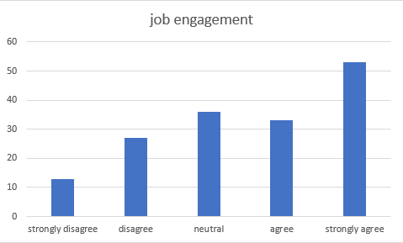
Q5 – Training improves the overall organization's profitability, effectiveness, productivity, and revenue, and other outcomes that are directly related to the training in improving the quality of service.
A total of 64 (39.0%) respondents of the population strongly agreed with the above statement, 48(28.0%) agreed, 35(20.0%) neither agreed nor disagreed, 4(2.0%) disagreed, and 11(7.0%) strongly disagreed.
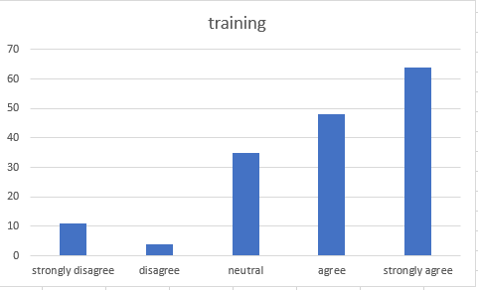
Q6 – Training improves the overall organization's profitability, effectiveness, productivity, and revenue, and other outcomes that are directly related to the training in improving the quality of service.
A total of 67 (42.0%) respondents of the population strongly agreed with the above statement, 41(25.0%) agreed, 32(20.0%) neither agreed nor disagreed,15(9.0%) disagreed, and 7(4.0%) strongly disagreed.
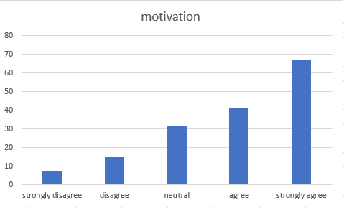
Q7 – At my job, I feel strong and vigorous.
A total of 34 (21.0%) respondents of the population strongly agreed with the above statement, 56(34.0%) agreed, 53(32.0%) neither agreed nor disagreed,14(8.0%) disagreed, and 8(5.0%) strongly disagreed.
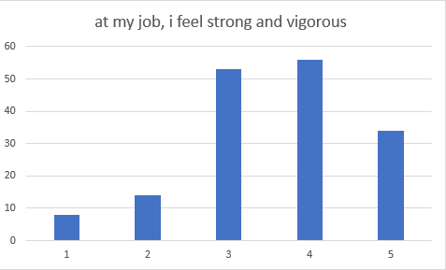
Q8 – At my work, I feel bursting with energy
A total of 36 (22.0%) respondents of the population strongly agreed with the above statement, 47(29.0%) agreed, 56(35.0%) neither agreed nor disagreed,14(9.0%) disagreed, and 9(5.0%) strongly disagreed.
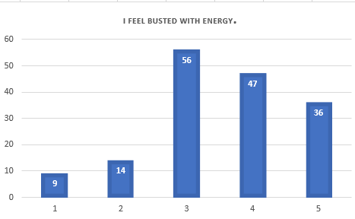
Q9 – I am enthusiastic about my job.
A total of 49 (30.0%) respondents of the population strongly agreed with the above statement, 45(28.0%) agreed, 40(25.0%) neither agreed nor disagreed,18(11.0%) disagreed, and 10(6.0%) strongly disagreed.
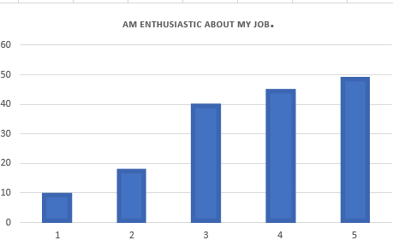

Q10 – my job inspires me
A total of 36 (22.0%) respondents of the population strongly agreed with the above statement, 47(29.0%) agreed, 56(35.0%) neither agreed nor disagreed,14(9.0%) disagreed, and 9(5.0%) strongly disagreed.
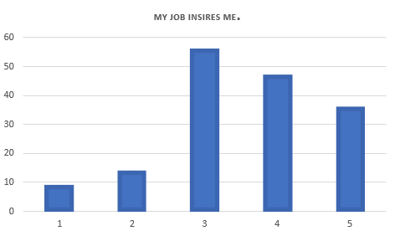
Q11 – when I wake up n the morning, I feel like going to work.
A total of 49 (28.0%) respondents of the population strongly agreed with the above statement, 34(20.0%) agreed, 36(21.0%) neither agreed nor disagreed,36(21.0%) disagreed, and 17(10.0%) strongly disagreed.
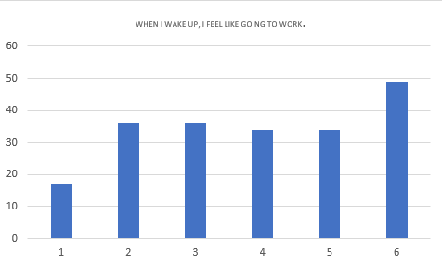
Q12 – I feel happy when I am working intensely
A total of 44 (27.0%) respondents of the population strongly agreed with the above statement, 52(32.0%) agreed, 42(26.0%) neither agreed nor disagreed,12(8.0%) disagreed, and 12(8.0%) strongly disagreed.
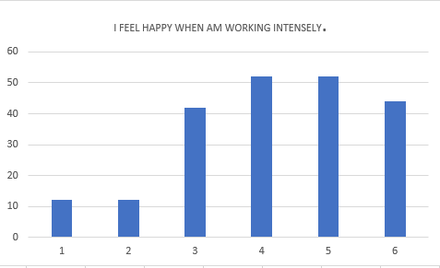
Q13 – Am proud of the work I do.
A total of 86 (53.0%) respondents of the population strongly agreed with the above statement, 42(26.0%) agreed, 17(10.0%) neither agreed nor disagreed,11(7.0%) disagreed, and 6(4.0%) strongly disagreed.
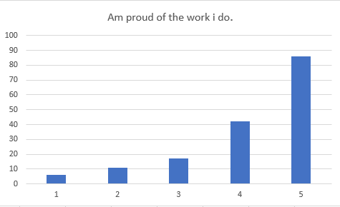
Q14 – I am immersed in my work.
A total of 57 (35.0%) respondents of the population strongly agreed with the above statement, 45(27.0%) agreed, 37(23.0%) neither agreed nor disagreed,12(8.0%) disagreed, and 11(7.0%) strongly disagreed.

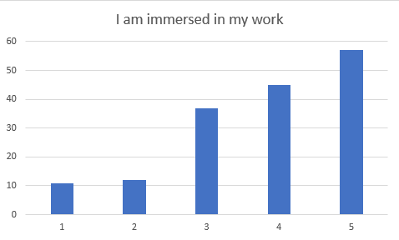
Q15– I get carried away when am working.
A total of 57 (35.0%) respondents of the population strongly agreed with the above statement, 44(27.0%) agreed, 39(24.0%) neither agreed nor disagreed,12(8.0%) disagreed, and 10(6.0%) strongly disagreed.
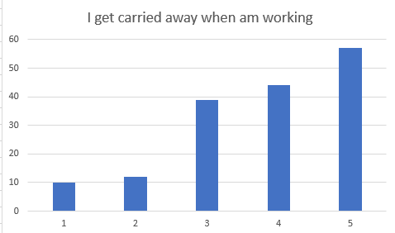
Q16– Am planning on working for another company within three years.
A total of 59 (39.0%) respondents of the population strongly agreed with the above statement, 33(20.0%) agreed, 28(17.0%) neither agreed nor disagreed,16(10.0%) disagreed, and 26(16.0%) strongly disagreed.
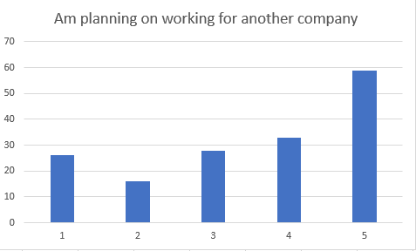
Q17– Within this company, my work gives me satisfaction
A total of 58 (38.0%) respondents of the population strongly agreed with the above statement, 35(21.0%) agreed, 30(22.0%) neither agreed nor disagreed,14(9.0%) disagreed, and 25(6.0%) strongly disagreed.
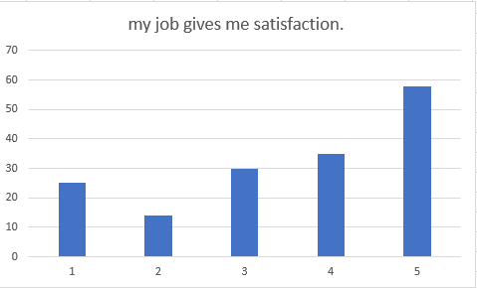
Q18– It doesn’t matter if am working for this company or another, as long as I have work.
A total of 50 (31.0%) respondents of the population strongly agreed with the above statement, 21(13.0%) agreed, 37(23.0%) neither agreed nor disagreed,24(18.0%) disagreed, and 30(18.0%) strongly disagreed.
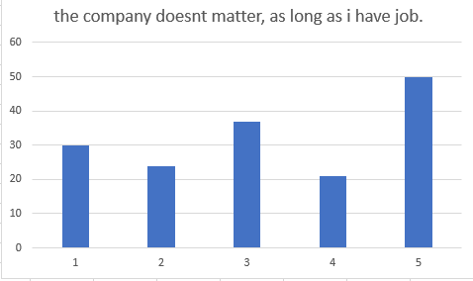
Q19– If I could start over again, I would choose to work for another company.
A total of 59 (39.0%) respondents of the population strongly agreed with the above statement, 33(20.0%) agreed, 28(17.0%) neither agreed nor disagreed,16(10.0%) disagreed, and 26(16.0%) strongly disagreed.
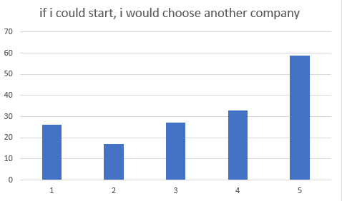
Q20– The work am doing is very important to me.
A total of 57 (35.0%) respondents of the population strongly agreed with the above statement, 44(27.0%) agreed, 39(24.0%) neither agreed nor disagreed,12(8.0%) disagreed, and 10(6.0%) strongly disagreed.
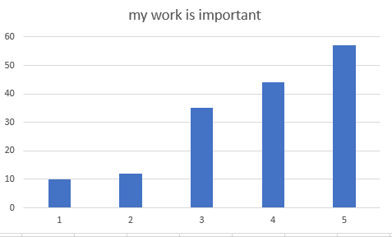
Q21– I perform well in the overall job by carrying out tasks as expected.
A total of 58 (38.0%) respondents of the population strongly agreed with the above statement, 35(21.0%) agreed, 30(22.0%) neither agreed nor disagreed, 25(6.0%) disagreed, and 14(9.0%) strongly disagreed.
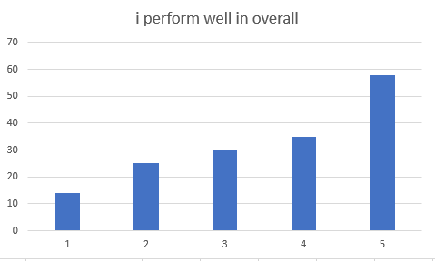
Q22– My organization promote an effective reward system
A total of 34 (21.0%) respondents of the population strongly agreed with the above statement, 32(20.0%) agreed, 41(26.0%) neither agreed nor disagreed,27(17.0%) disagreed, and 26(16.0%) strongly disagreed.
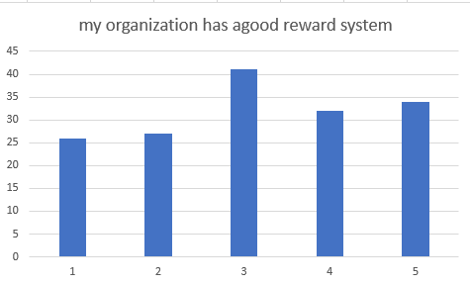
Q23– Employees have the perception to acquire new knowledge and skills which they apply on the job and also share with another employee
A total of 57 (35.0%) respondents of the population strongly agreed with the above statement, 44(27.0%) agreed, 39(24.0%) neither agreed nor disagreed,12(8.0%) disagreed, and 10(6.0%) strongly disagreed.
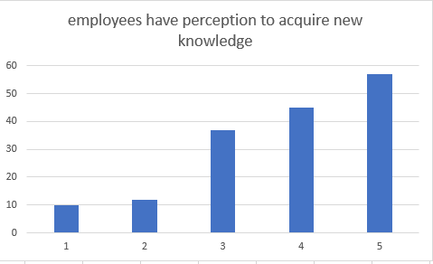
Q24– Training improves the overall organization's profitability, effectiveness, productivity, and revenue, and other outcomes that are directly related to the training in improving the quality of service.
A total of 50 (31.0%) respondents of the population strongly agreed with the above statement, 61(38.0%) agreed, 36(22.0%) neither agreed nor disagreed,4(2.0%) disagreed, and 11(7.0%) strongly disagreed.
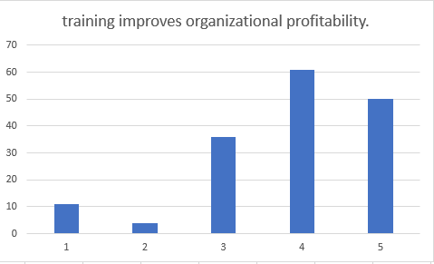
Q25– Conflict that such instructing would increase the value of the association by helping its workers develop and create and consequently improve the general generation.
A total of 57 (35.0%) respondents of the population strongly agreed with the above statement, 44(27.0%) agreed, 39(24.0%) neither agreed nor disagreed,12(8.0%) disagreed, and 10(6.0%) strongly disagreed.
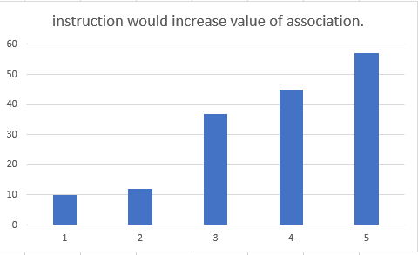
Q26– My organization support further development of employee skills related to required duties of the job
A total of 54 (33.0%) respondents of the population strongly agreed with the above statement, 41(25.0%) agreed, 36(22.0%) neither agreed nor disagreed,20(13.0%) disagreed, and 11(7.0%) strongly disagreed.
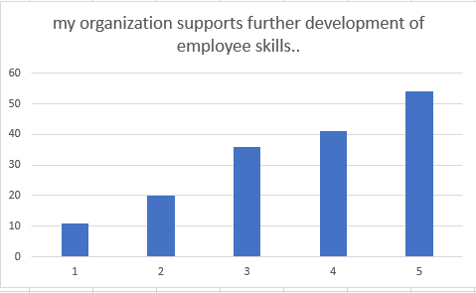
Q27– Drilling and tutoring can give an adaptable responsive advancement approach that can use to bolster an expanding number of people inside the association than conventional types of preparing consequently vocation development.
A total of 43 (27.0%) respondents of the population strongly agreed with the above statement, 46(28.0%) agreed, 50(31.0%) neither agreed nor disagreed,12(7.0%) disagreed, and 11(7.0%) strongly disagreed.
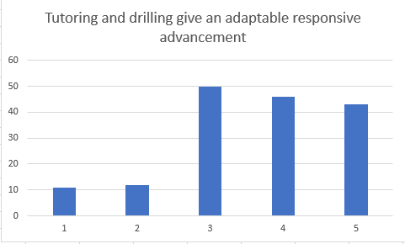
Q28– I willingly attend functions not required by the organization but helps in its overall image.
A total of 44 (27.0%) respondents of the population strongly agreed with the above statement, 52(32.0%) agreed, 42(26.0%) neither agreed nor disagreed,12(8.0%) disagreed, and 12(8.0%) strongly disagreed.
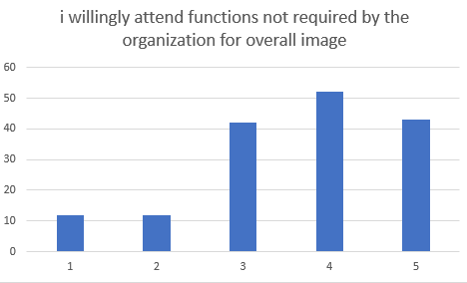
Q29– I take initiative to orient new employees to the department even though not part of my job description.
A total of 52 (32.0%) respondents of the population strongly agreed with the above statement, 42(26.0%) agreed, 42(26.0%) neither agreed nor disagreed,13(8.0%) disagreed, and 13(8.0%) strongly disagreed.
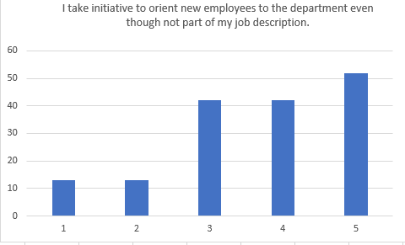
Q30– I help other employees with their work when they have been absent.
A total of 42 (26.0%) respondents of the population strongly agreed with the above statement, 50(31.0%) agreed, 46(28.0%) neither agreed nor disagreed,14(9.0%) disagreed, and 10(6.0%) strongly disagreed.
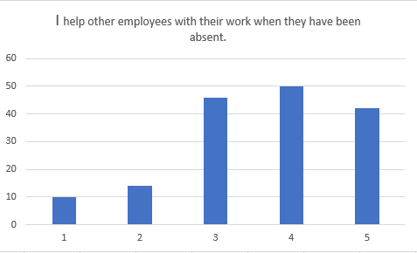
Q31– I am aware of my organization values, beliefs, and behaviors
A total of 81 (39.0%) respondents of the population strongly agreed with the above statement, 34(26.0%) agreed, 32(24.0%) neither agreed nor disagreed, 10(7.0%) disagreed, and 5(4.0%) strongly disagreed.
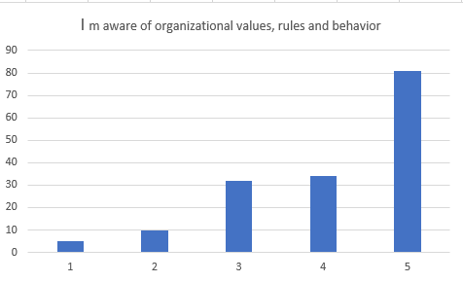

Descriptive Analysis.

The demographic details of the sample size that 162 were gender, education, and the age of the respondents. The male participants were 65.43% (n=106) while 34.57% were female respondents are in this study. Moreover, the age showed 76 (47%) people below thirty years, 63(39%) between 31 years and 4o years, 12(7%) between 41 and 50 years, and 12(7%) above 51 years.
 | category | Frequency | Percent
Gender | Male | 106 | 65.34
 | Female | 54 | 34.57
 | Total | 162 | 100.0
Age | Below 30 | 76 | 47
 | 31 to 40 | 63 | 39
 | 41 to 50 | 12 | 7
 | 51 and above | 12 | 7
 | Total | 162 | 100.0
Education | Bachelors | 94 | 58.02
 | Masters | 58 | 41.98
 | Total | 162 | 100

The analysis of the mean was noted as to be between 4.13 and 7.33 and the standard deviation was noted as from 2.564 to 3.7889. On a scale of 1 to 5, the results have illustrated that the mean of employees that agreed to employee engagement of mean of 7.33 and an SD of 3.7889.

Item | N | mean | Standard deviation
Employee engagement | 162 | 7.33 | 3.7889
Employee retention | 162 | 6.60 | 2.8
Employee performance | 162 | 5.88 | 3.1342
Workplace culture | 162 | 5.48 | 3.22
Employee training | 162 | 5.00 | 2.963
Employee motivation | 162 | 4.13 | 2.564

Moreover, when analyzing the consistency of the variable, Cronbach’s reliability was calculated. The entire reliability was found to be 0.929 for n=162.
Reliability Statistics
Cronbach's Alpha | N of Items
.929 | 48

The individual factors were satisfactory.

S .No | Factor | No. of items | α (alpha)
1 | Employee engagement | 09 | 0.888
2 | Employee retention | 05 | 0.309
3 | Employee performance | 06 | 0.829
4 | Workplace culture | 06 | 0.850
5 | Employee training | 06 | 0.858
6 | Employee motivation | 10 | 0.823

HYPOTHESES TESTING

Pearson’s correlation.
Pearson's correlation is a bivariate analysis whose aim is to measure the association strength between two variables. Since all the values are positive, it indicates that there was a perfect degree between the two variables. As Pearson's correlation values move towards zero, then the relationship. If the value is moving towards one, then the association is strong. For instance, the values of employee motivation have improved from 0.258 to 0.702 showing that the relationship is a positive one.
Regression analysis is a technique used for the analysis of multiple data based on correlation, probability, distributions, t-scores, and hypothesis testing. In regression analysis, these factors may be divided into dependent and independent variables. Dependent variables represent the factors you are trying to study while independent variables represent the factors that have an impact on your dependent variable (Bates et al, 1988). R represents the coefficient of correlation between the two components. A positive value of R indicates a perfect relationship while a 0-correlation coefficient indicates there is no relationship between the two variables. The result shows the value of R as 0.377 which shows that the variables will form a perfect tandem. The r-square indicates how efficiently the regression line fits the data. It shows the percentage of variation between those elements.
By using Pearson's correlation and multiple regression the proposed hypotheses were confirmed. The weightage score explores that (r = 0.246**; β = 0.319; t = 0.384; p < 0.01. Hence; hypothesis H1 was accepted that employee engagement influences the retention of employees within a given organization. Hypothesis H2 was also accepted that employee performance determines employee retention with the weightage score showing (r = 0.475**; β = 0.319; t = 0.384; p < 0.01. Moreover, hypothesis H3 was accepted that the culture of the workplace determines how employees are retained within the organization with the weightage score showing (r = 0.547**; β = 0.319; t = 0.384; p < 0.01. Hypothesis H4 accepts that employee training influences employee retention with the weightage score showing (r = 0.606**; β = 0.319; t = 0.384; p < 0.01. and hypothesis H5 accepts that employee motivation influences retention of employees with the weightage score showing (r = 0.702**; β = 0.319; t = 0.384; p < 0.01).

Variables | 1 | 2 | 3 | 4 | 5 | 6
1.Employee retention | ---
2.Employee engagement | 0.246** | ---
3.Employee performance | 0.361** | 0.475** | ---
4.Workplace culture | 0.266** | 0.709** | 0.547** | ---
5.Employee training | 0.251** | 0.572** | 0.477** | 0.606** | ----
6.Emplyee motivation | 0.258** | 0.549** | 0.513** | 0.582** | 0.702** | ----

Model Summary^{b}
Model | R | R Square | Adjusted R Square | Std. Error of the Estimate
1 | .377ª | .142 | .114 | 3.02836
a. Predictors: (Constant), Employee motivation, Employee performance, Employee engagement, Employee training, Workplace culture
b. Dependent Variable: Employee retention

Coefficientsª
Model |  | Unstandardized Coefficients |  | Standardized Coefficients | t | Sig.
 |  | B | Std. Error | Beta | t | Sig.
1 | (Constant) | 6.272 | 1.489 |  | 4.212 | .000
1 | Employee engagement | .319 | .050 | .042 | .384 | .002
1 | Employee performance | .232 | .077 | .281 | 3.021 | .003
1 | Workplace culture | .221 | .080 | .031 | .268 | .009
1 | Employee training | .034 | .084 | .046 | .406 | .685
1 | Employee motivation | .020 | .056 | .040 | .363 | .717
a. Dependent Variable: Employee retention

Chapter five

Results Discussions, Conclusions, Implications, Limitations and Recommendations

Discussion.
In the economic world today, the responsibilities of ensuring that skilled and hardworking employees are retained within the organization fall on the higher management of every organization. In recent years, employers have found out that employee turnover may be due to the following reasons. . Firstly, lack of career growth and progress may cause an employee to change careers or move to a newer organization that appreciates their efforts. Secondly, working overtime with no extra pay kills the motivation of some employees thus encouraging them to move to other business organizations. Moreover, a lack of feedback or recognition and support from project managers shows the employees that the organization is not investing in their jobs hence they lack the motivation to continue working. Also, the absence of rewards for work-well-done and compensation for sick leaves or work accidents makes the employee think that their well-being is not guaranteed in that particular organization. Besides, if an organization does not offer opportunities for promotions and room for decision making for some management employees may cause those employees to move to new firms and organizations.
Following the results for H1, the results show that a positive employee engagement will lead to increased retention within an organization. The results for Hypothesis H2 show that the employees’ performance within an organization can determine their retention within an organization. Moreover, the hypothesis H3 shows that a positive culture within the organization can maintain high retention level of skilled employees. Furthermore, the hypothesis H4 shows that offering training can ensure employees are retained. Lastly, the hypothesis H5 shows that motivating the employees and offering rewards will ensure that employee turnover is reduced while retention is improved. According to (Michaels et al, 1982), observing the commitment of an employee to the organization and their expectations from that particular job highly assists the management of an organization to determine whether the employees are highly satisfied with their jobs and whether they have the intention of quitting their job in the near or far future. Moreover, the higher the number of employees retained by an organization, the higher the productivity of the organization since the level of operational activities is also increased. According to (Malik et al, 2013), an increase in the rate of employee retention leads to an increase in organizational productivity while an increase in the rate of employee turn-over reduces the general rate of productivity.
CONCLUSION AND RECOMMENDATIONS.

The chapter discusses a synopsis of the findings, it gives a general conclusion and offers recommendations for future study on employee retention. The goal of the study was to establish the effect of workplace culture on employee retention, to establish how training influences, employee retention, to assess how the availability of motivation influences employee retention, to analyze how job performance influences employee retention and, to assess how work engagement influences employee retention. The first part involved understanding the significance of the research and the methodologies used data collection. The second part deals with the different factors that affect employee retention within the organization. Part three deals with the analysis of results after the collection. The recommendations arising from the study have been described in this last chapter.
Data analysis is useful because it helps an organization or a business firm comprehend the challenges and problems facing the organization by developing structures and visualizations that help in the interpretation of the data. From the data collected in this research, the analysis involved the following steps: First, it involves the preparation of a grid where the data from the questionnaires will be written. Secondly, developing a coding system to check the comprehensiveness and completeness of the questions and answers from the questionnaires. From the results, it is seen that some factors positively influence the retention of employees while others negatively influence. For instance, motivation and training will make an employee stay longer in an organization while a lack of health insurance, and lack of engagement will make an employee consider moving to a different company. According to (Kalid et al, 2018), human resource management strategies are not enough to ensure the retention of employees. Therefore, most organizations are determined to find better methods of ensuring retention by accommodating employees' needs rather than depending on the traditional methods. The utilization of Cronbach's alpha test, the regression analysis, and Pearson's correlation can help the researcher understand the analyzed data in a more simplified way. The area of examination of data assembled the major factors affecting the retention of employees. Data analyzed was in the form of demographic data, the relationship between those elements. Therefore, determining connections between dependent and independent variables can assist in the comprehension of the collected data.

Limitations
This research on employee retention had some limitations. The major limitation for this study was that no follow-up information was available after the study to determine if an organization changed their methods of employee retention or check whether employees altered their decisions about moving to new firms. Therefore, the research speculated that the performance of the organization, training remained the same, and engagement remained the same throughout the entire existence of the organization. Moreover, the research was unable to determine the long term effects of employee retention and turnover on both the organization and the employees.

Recommendations.

To ensure that employee retention is achieved, the organization can follow the following precautions. First, the organization might keep collaboration between management and the employees to encourage good ethics amongst them. That is, for the employees to work in harmony, they need to take issues into considerations to ensure personal matters do not interfere with work ethics. Moreover, the organization should review salary, promotion, and benefits issues to increase retention. For instance, employees will feel well taken care of if they get vacations, after-hour payments, and medical insurances. Moreover, maintaining a favorable environment in an organization can help reduce the rates of employees leaving organizations for better jobs. Therefore, proper inspiration and motivation, work engagement, providing a favorable working culture, and providing training can help improve employee retention
For future study, the organization can do a further survey to determine the attitudes of management and whether or not they influence employee retention.

References.

Allen, D.G., Bryant, P.C., & Vardman, J.M. (2010). Retaining talent: Replacing misconceptions with evidence-based strategies. Academy of Management Perspectives, 24, 48-64.
Bates, D. M., & Watts, D. G. (1988). Nonlinear regression analysis and its applications (Vol. 2). New York: Wiley.
Khalid, K., & Nawab, S. (2018). Employee participation and employee retention because of compensation. SAGE Open, 8(4), 2158244018810067.
Malik, M. I., Sajjad, M., Hyder, S., Ahmad, M. S., Ahmed, J., & Hussain, S. (2013). Role overload: A cause of diminishing employee retention and productivity. Middle-East Journal of Scientific Research, 18(11), 1573-1577.
Michaels, C. E., & Spector, P. E. (1982). Causes of employee turnover: A test of the Mobley, Griffeth, Hand, and Meglino model. Journal of applied psychology, 67(1), 53
Aguenza, B. B., & Som, A. P. M. (2012). Motivational factors of employee retention and engagement in organizations. International journal of advances in management and economics, 1(6), 88-95.
Chandani, A., Mehta, M., Mall, A., & Khokhar, V. (2016). Employee engagement: A review paper on factors affecting employee engagement. Indian Journal of Science and Technology, 9(15), 1-7.
Das, B. L., & Baruah, M. (2013). Employee retention: A review of literature. Journal of Business and Management, 14(2), 8-16.
Irshad, M., & Afridi, F. (2007). Factors affecting employees retention: Evidence from literature. Abasyn Journal of Social Sciences, 4(2), 307-339.
Liang, Z. (2013). Knowledge and influencing factors of employee retention (Doctoral dissertation, Dublin, National College of Ireland).
Kaur, R. (2017). Employee retention models and factors affecting employees retention in IT companies. International Journal of Business Administration and Management, 7(1), 161-174.
Muhoho, J. M. (2014). Assessment of factors influencing employee retention in Tanzania's work organisations. International Journal of Innovation and Applied Studies, 9(2), 687.
Nasir, S. Z., & Mahmood, N. (2016). Determinants of employee retention: an evidence from Pakistan. International Journal of Academic Research in Business and Social Sciences, 6(9), 182-194.
Park, C., McQuaid, R., Lee, J., Kim, S., & Lee, I. (2019). The impact of job retention on continuous growth of engineering and informational technology SMEs in South Korea. Sustainability, 11(18), 5005.
Parvin, M. M., & Kabir, M. N. (2011). Factors affecting employee job satisfaction of pharmaceutical sector. Australian journal of business and management research, 1(9), 113.
Ramlall, S. (2003). Organizational application managing employee retention as a strategy for increasing organizational competitiveness. Applied HRM research, 8(2), 63-72.
Senevirathna, E. (2017). Factors affecting employee retention. International Business Management. Retrieved from https://www.researchgate.net/publication/318920807_Factors_Affecting_Employee_Retention
Shakeel, N., & But, S. (2015). Factors influencing employee retention: An integrated perspective. Journal of Resources Development and Management, 6(2015), 32-49.
Sinha, C., & Sinha, R. (2012). Factors affecting employee retention: A comparative analysis of two organizations from heavy engineering industry. European journal of business and management, 4(3), 145-162.
Tadesse, W. M. (2018). Factors Affecting Employee Retention in Ethiopian Public Organizations. Journal of Strategic Human Resource Management, 7(3), 22.
Thakur, A. (2014). A study on factors affecting employee retention in retail sector. International journal of multidisciplinary consortium, 1(1), 37-54.
Verma, D. S., & Chaurasia, R. (2016). A study to identify the factors affecting employee turnover in small scale industries. International Journal of Engineering Sciences and Research Technology, 5(7), 638-652.
Walangitan, B. N., Pangemanan, S. S., & Tumewu, F. (2014). The analysis of factors affecting employee retention at Pt. Hasjrat Abadi Manado. Jurnal EMBA: Jurnal Riset Ekonomi, Manajemen, Bisnis dan Akuntansi, 2(1).
Yousuf, S., & Siddiqui, D. A. (2019). Factors Influencing Employee Retention: A Karachi Based Comparative Study on IT and Banking Industry. Yousuf, S. and Siddiqui, DA (2019). Factors Influencing Employee Retention: A Karachi Based Comparative Study on IT and Banking Industry. International Journal of Human Resource Studies, 9(1), 42-62.
Zachariah, M., & Roopa, T. N. (2012). A study on employee retention factors influencing it professionals of Indian IT companies and multinational companies in India. Interdisciplinary Journal of contemporary research in business, 4(7), 449-466.
Bureau of Labor Statistics. (2020, July 28). Annual Employee retention Statistisc, Civilian labor force 16 years and over. Retrieved from http://www.bls.gov/cpsm
Deery, M. A. R. G. A. R. E. T. (2009). Employee retention strategies for event management. People and Work in Events and Conventions: A Research Perspective, 127.
Deery, M., & Jago, L. (2015). Revisiting talent management, work-life balance and retention strategies. International Journal of Contemporary Hospitality Management.
Herman, R. E. (2005). HR managers as employee-retention specialists. Employment Relations Today, 32(2), 1.
Rizwan, M., Arshad, M. Q., Munir, H. M. A., Iqbal, F., & Hussain, A. (2014). Determinants of Employees intention to leave: A Study from Pakistan. International Journal of Human Resource Studies, 4(3), 1-18.
HR’S, A. M. B. I. T. I. O. N. S. (1995). Employee turnover. Work, 10, 0.
Kaur, R. (2017). Employee retention models and factors affecting employees retention in IT companies. International Journal of Business Administration and Management, 7(1), 161-174.
Amissah, E., Gamor, E., Deri, M., & Amissah, A. (2016). Factors influencing employee job satisfaction in Ghana's hotel industry. Journal of Human Resources in Hospitality and Tourism , 15(2), 166-183. doi:https://doi.org/10.1080/15332845.2016.1084858
Niguse, G. (2019). The effects of organizational culture on turnover intention: The mediating role of job satisfaction, a case of Oromia Forest and Wild Life Enterprise. African Journal of Business Management, 13(2), 82-89. Retrieved from https://academicjournals.org/journal/AJBM/article-full-text-pdf/D70752C59838
Rakhra, H. (2018). Study on factors influencing employee retention in companies. International Journal of Public Sector Perfomance, 4(1), 57-79. Retrieved from https://www.inderscienceonline.com/doi/pdf/10.1504/IJPSPM.2018.088695
Sundar, K. (2019, September). A STUDY ON ORGANIZATIONAL FACTORS INFLUENCING EMPLOYEE RETENTION IN ROOTS INDUSTRIES INDIA LTD, COIMBATORE. KCT Business School, 1-41. Retrieved from https://www.researchgate.net/profile/Sundar_Kr/publication/342500238_A_STUDY_ON_ORGANIZATIONAL_FACTORS_INFLUENCING_EMPLOYEE_RETENTION_IN_ROOTS_INDUSTRIES_INDIA_LTD_COIMBATORE/links/5ef7499892851c52d600776a/A-STUDY-ON-ORGANIZATIONAL-FACTORS-INFLUENCING-EMP
Wachira, J. (2018). Factors Influencing Employee Retention at International Research Institutes: A Case of the International Livestock Research Institute (ILRI). USIU Digital repository, 1-20. Retrieved from http://erepo.usiu.ac.ke/handle/11732/4377
Aguenza, B. B., &amp; Som, A. P. M. (2012). Motivational factors of employee retention and engagement in organizations. International journal of advances in management and economics, 1(6), 88-95.
Aguenza, B., & Som, A. (2012). Motivational Factors of Employee Retention and Engagement in Organizations. International Journal of Advances in Management and Economics, 1(6), 88-95. Retrieved from http://managementjournal.info/index.php/IJAME/article/download/233/222
Ghimire, P. (2018). Employee Retention Factors in Nepali Insurance companies. Journal of Business and Social Sciences , 2(1). doi:1S0.3126/jbss.v2i1.22828
Goperma, C., & Dolai, S. (2018). AN ANALYSIS OF FACTORS INFLUENCING EMPLOYEES INTENTION TO STAY IN THE ORGANIZATION. Journal of Emerging Technologies and Innovative Research (JETIR), 5(1), 970-983. Retrieved from http://www.jetir.org/papers/JETIR1801185.pdf
Hadi, N., & Ahmed, S. (2018). Role of Employer Branding Dimensions on Employee Retention: Evidence from Educational Sector. Admistritive Sciences Journal, 8(3). doi:10.3390/admsci8030044
Ingersoll, M., May, H., & Collins, G. (2019). Recruitment, Employment, Retention and the Minority Teacher Shortage. Education Policy Analysis Archives, 27(37). doi:10.14507/epaa.27.3714
Das, B., & Baruah, M. (2013). Employee Retention: A Review of Literature. IOSR Journal of Business and Management (IOSR-JBM), 14(2), 8-16. Retrieved from https://www.researchgate.net/profile/Filip_Dochy/publication/225802431_Employee_Retention_Organisational_and_Personal_Perspectives/links/09e415139a443e954a000000/Employee-Retention-Organisational-and-Personal-Perspectives.pdf
Nasir, S., & Mahmood, N. (2016). Determinants of Employee Retention: An Evidence from Pakistan. International Journal of Academic Research in Business and Social Sciences, 6(9), 182-194. Retrieved from http://hrmars.com/hrmars_papers/Determinants_of_Employee_Retention_An_Evidence_from_Pakistan.pdf
Nayak, B., & Ben, J. (2019). Employee Retention in the VUCA World: Challenges and Strategies. International Journal of Recent Technology and Engineering (IJRTE), 8(3), 84-88. Retrieved from https://www.ijrte.org/wp-content/uploads/papers/v8i3S2/C10141083S219.pdf
Almaaitah, M., Harada, Y., Sakdan, M., & Almaaitah, A. (2017). Integrating Herzberg and Social Exchange Theories to Underpinned Human Resource Practices, Leadership Style, and Employee Retention in Health Sector. World Journal of Business and Management, 3(1), 16-34. Retrieved from https://www.researchgate.net/profile/Mohammad_Almaaitah2/publication/316328040_Integrating_Herzberg_and_Social_Exchange_Theories_to_Underpinned_Human_Resource_Practices_Leadership_Style_and_Employee_Retention_in_Health_Sector/links/5a4e1aa1aca2729b7c8c1cb
Nasir, F., Ashraf, M., & Riaz, M. (2019, June). The Role of Gender in Employee Retention: A Study of Private Hospitals in Karachi. International Journal of Experiential Learning & Case Studies, 4(1), 157-171. doi:http://dx.doi.org/10.22555/ijelcs.v4i1.2595.g537

Appendices
Demography (please tick the relevant box)
- Gender Male Female
- Age 30 and below 31 to 40 41 to 50 51 and above
- Education Bachelors Masters Any Other Degree
- Length of service 0 to 2 yrs 3 to 5 yrs 6 yrs and above
- No. of dependents 0 - 2 3 – 4 5 or above
The aim of this survey is to identify the impact of different factors over the employee retention. With respect to your own feelings about the particular organization for which you are now working please indicate the degree of your agreement or disagreement with each statement by checking one of the five alternatives below for each statement in the given space.
Strongly disagree = 1, moderately disagree = 2, neither agree nor disagree = 3, moderately agree = 4, strongly agree = 5
- Employee Engagement (This Is related with the strength of the mental and emotional connection employees feel toward their places of work)
1 | At my work, I feel bursting with energy | 1 | 2 | 3 | 4 | 5
2 | At my job, I feel strong and vigorous. | 1 | 2 | 3 | 4 | 5
3 | I am enthusiastic about my job. | 1 | 2 | 3 | 4 | 5
4 | My job inspires me. | 1 | 2 | 3 | 4 | 5
5 | When I get up in the morning, I feel like going to work. | 1 | 2 | 3 | 4 | 5
6 | I feel happy when I am working intensely. | 1 | 2 | 3 | 4 | 5
7 | I am proud of the work I do. | 1 | 2 | 3 | 4 | 5
8 | I am immersed in my work. | 1 | 2 | 3 | 4 | 5
9 | I get carried away when I am working. | 1 | 2 | 3 | 4 | 5

- Employee Retention: (It is the process by which a company ensures that its employees don't quit their jobs)
10 | I’m planning on working for another company within a period of three years | 1 | 2 | 3 | 4 | 5
11 | Within this company my work gives me satisfaction | 1 | 2 | 3 | 4 | 5
12 | It doesn’t matter if I’m working for this company or another, as long as I have work. | 1 | 2 | 3 | 4 | 5
13 | If I could start over again, I would choose to work for another company. | 1 | 2 | 3 | 4 | 5
14 | The work I’m doing is very important to me. | 1 | 2 | 3 | 4 | 5

- Employee Performance (It is related as how an employee fulfills their job duties and executes their required tasks)
15 | I achieve the objectives of the job | 1 | 2 | 3 | 4 | 5
16 | I fulfil all the requirements for my job | 1 | 2 | 3 | 4 | 5
17 | I perform well in the overall job by carrying out tasks as expected. | 1 | 2 | 3 | 4 | 5
18 | I willingly attend functions not required by the organization but helps in its overall image. | 1 | 2 | 3 | 4 | 5
19 | I take initiative to orient new employees to the department even though not part of my job description | 1 | 2 | 3 | 4 | 5
22 | I help other employees with their work when they have been absent | 1 | 2 | 3 | 4 | 5

- Workplace Culture (It is related with the shared values, belief systems, attitudes and the set of assumptions that people in a workplace share)
21 | I am aware of my organization values, beliefs, and behaviors. | 1 | 2 | 3 | 4 | 5
22 | I describe my workplace environment as a culture that is trusting, honest and fair to all employees. | 1 | 2 | 3 | 4 | 5
23 | I think culture affect behaviors and performance in my organization. | 1 | 2 | 3 | 4 | 5
24 | My organization support further development of employee skills related to required duties of the job. | 1 | 2 | 3 | 4 | 5
25 | My organization measure employee engagement | 1 | 2 | 3 | 4 | 5
26 | My organization promote effective reward system | 1 | 2 | 3 | 4 | 5

- Employees Training (It is related with the way of how the employees could improve their skills and work on their weaknesses).
27. | Employees have perception to acquire new knowledge and skills which they apply on the job and also share with other employees. | 1 | 2 | 3 | 4 | 5
28. | Training improves the overall organization profitability, effectiveness, productivity, and revenue and other outcomes that are directly related to the training in improving the quality of service. | 1 | 2 | 3 | 4 | 5
29 | Conflict that such instructing would increase the value of the association by helping its workers develop and create and consequently improve general generation and gainfulness was likewise underscored. | 1 | 2 | 3 | 4 | 5
430 | Drilling and tutoring can possibly give an adaptable responsive advancement approach that can use to bolster an expanding number of people inside the association than conventional types of preparing consequently vocation development. | 1 | 2 | 3 | 4 | 5
31 | A career issue interlaces with different issues and circumstances in an individual's life. | 1 | 2 | 3 | 4 | 5
32. | Little changes in worker conduct can have huge effect on business execution. | 1 | 2 | 3 | 4 | 5

- Employees Motivation (It is related to high quality of work to be more creative).
33 | My Supervisor supports me in balancing my family and work demand. | 1 | 2 | 3 | 4 | 5
34 | The degree of skill variety required to perform my job has an impact on my motivation. | 1 | 2 | 3 | 4 | 5
35 | How meaningful I believe my work has influence on my motivation level. | 1 | 2 | 3 | 4 | 5
36 | Employees are highly motivated with reward motivational factor | 1 | 2 | 3 | 4 | 5
37 | Employees are less motivated with interesting work and training and development. | 1 | 2 | 3 | 4 | 5
38 | Motivational factors that are crucial in influencing employee retention are financial rewards, job characteristics, career development, recognition, management and work-life balance. | 1 | 2 | 3 | 4 | 5
39 | Empowering is allowing employees to greater freedom, autonomy and self-control over their work and responsibility for decision-making. | 1 | 2 | 3 | 4 | 5
40 | Every person has different reason for working. | 1 | 2 | 3 | 4 | 5
41 | One of the keys to avoiding turnover is to make rewards count. | 1 | 2 | 3 | 4 | 5
42 | Employee involvement is positively related to employee performance and job satisfaction. | 1 | 2 | 3 | 4 | 5

Thanks for Taking Your Time

